**Jean Dissevelt opens arts and crafts display 1984**

Peak Hill Leisure Arts and Craft Centre was ablaze with the products of many fine local talents on the weekend.

A good deal of preparation had obviously gone into the staging of the tenth annual art exhibition and the tiny, six-room building was especially packed at the opening on Friday night when locals and out-of-town art enthusiasts crammed into the centre to catch a glimpse of the prize-winning pieces.

The exhibition was officially declared open at 8.30pm, Friday, by former Peak Hill resident, Mrs Jean Dissevelt who was the foundation president of the arts centre more than ten years ago. She said the displays and quality of the local work produced was ‘just fantastic’ and that the work was certainly of a ‘professional standard’.

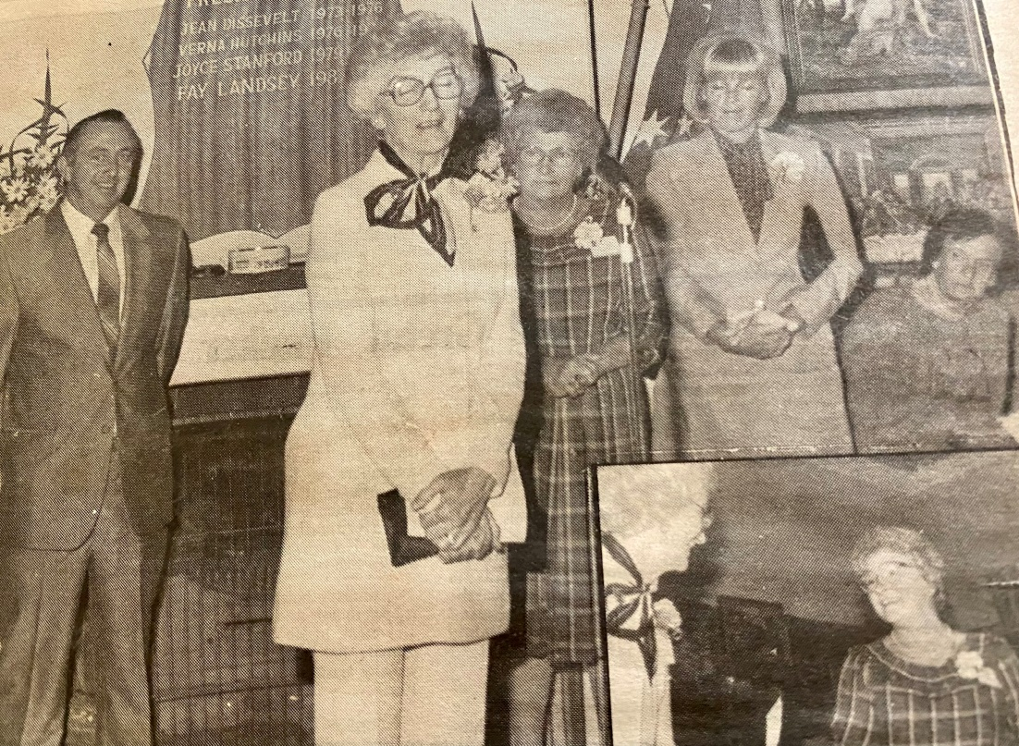Councillor Robert Wilson represented Parkes Shire Council at the opening and commented on the standard of work exhibited and passed the congratulations of the Council onto the hard-working members of the Arts Centre.

President of the Leisure Arts and Craft Centre, Mrs Fay Landsey, thanked all members for their ‘wonderful support’ and also expressed her appreciation to the Shire Council for donating the centre in which the artwork is housed and annually exhibited.

Mrs Landsey thanked secretary, Dorothy Lincoln, for her support attributing much of the success of the exhibition to Dorothy’s tireless efforts. *Cindy Lynch*

*Pictured: Councillor Robert Wilson, Foundation member, Jean Dissevelt and President Fay Landsey*