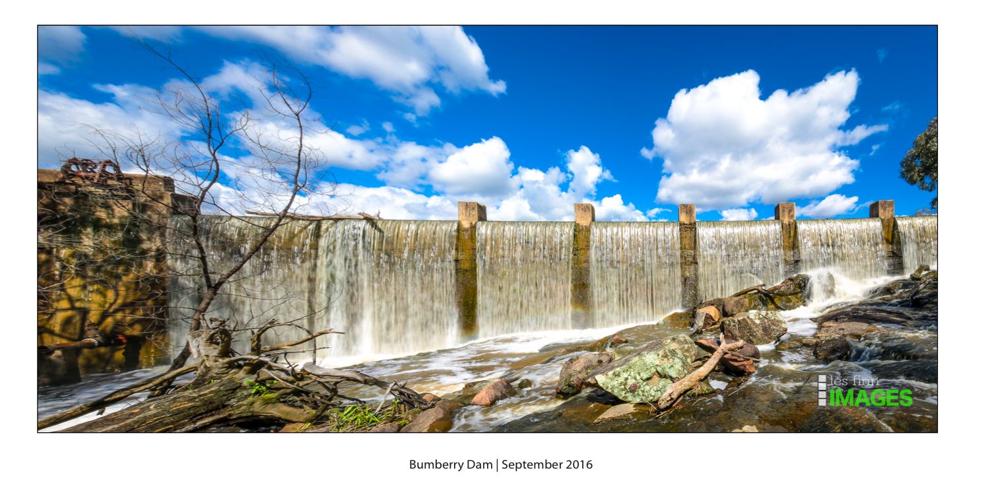



**Parkes Shire Council**

**Water Brief**

# Current Water Situation and Studies for Parkes

Communities also must take responsibility for their water security. Being remote from natural water sources, Parkes’ water supply would be vulnerable without managed intervention. In addition, key sectors that underpin the local economy such as mining and agriculture are heavy water users, placing additional demand on our supply.

Parkes Shire Council has been proactively working towards future-proofing water security for the Shire. To address recurring water shortages, ageing infrastructure, and to plan for vulnerabilities that arise from being largely rainfall-dependent in a changing climate, Parkes Shire Council became one of the first LGAs to undertake an Integrated Water Management Strategy (IWCM) in 2004. The IWCM identified water management issues and potential solutions 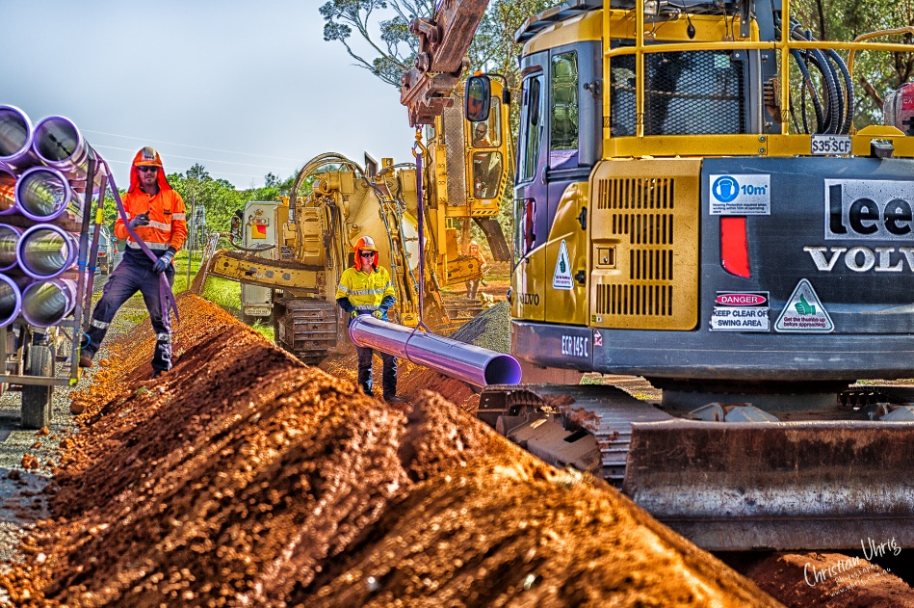After a decade of forward planning and extensive community consultation, Council embarked on the Parkes Integrated Water Infrastructure Renewal Program; a once-in-a-lifetime overhaul of Parkes urban water supply and wastewater schemes in one package of works valued at over $100 million dollars which included a new Lachlan River Intake System, refurbishment of bores, new water and sewage treatment plants, an upgrade to Lake Endeavour Dam and the implementation of a recycled water scheme throughout town.

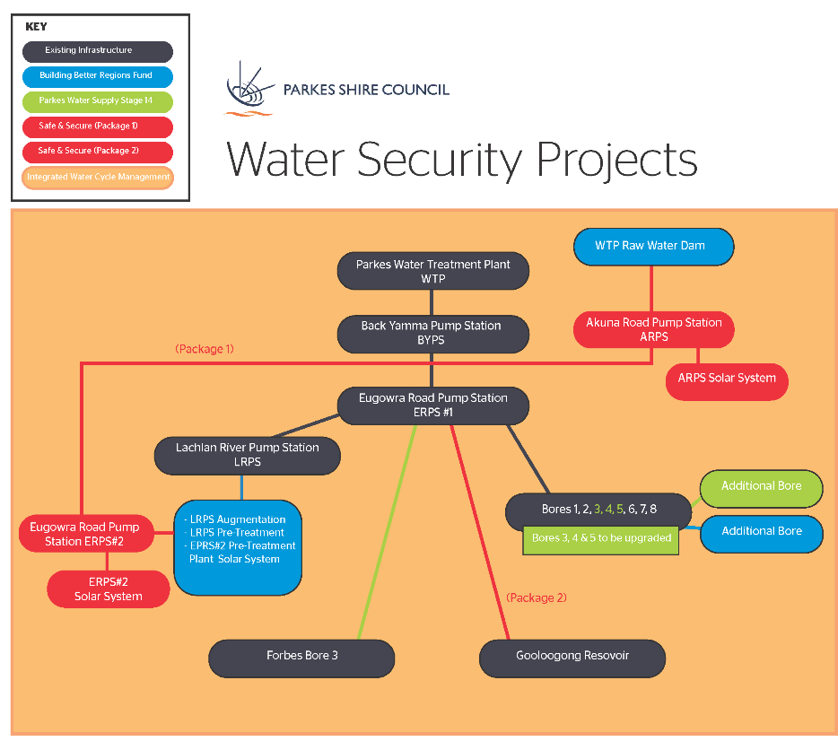

**Integrated Water Cycle Management Plan (IWCM)   
Funding: Safe and Secure Water program Stream 2 $300k State + NPM $100k = $400K**

IWCM strategy is usually a document which predicts growth out to 30 years, however due to the significant amount of water projects undertaken by Parkes Shire Council and the considerable developments announced for the community such as the State Government's Parkes Special Activation Precinct and the expansion of Northparkes Mines with a vision of a century of mining, these demand projections needed to be revised.

**Challenge we are trying to address**

Current Parkes water infrastructure can transfer 240l/s. Due to the growth in areas such as construction and the SAP we are already struggling to meet demand (transfer capacity/river water quality issues).

Currently we are assuming the following growth options:

* Low – 400l/s
* Medium – 500l/s
* High – 600l/s

Central scenario: 500l/s by mid 2050s – (NPM, 150l/s; PSC, 225l/s; SAP, 275l/s)

**Safe and Secure Water INSW Business Case - State Funding $2 million**

Parkes Shire Council have received just over a $1m worth of funding, matched by Council, to develop a business case for Infrastructure NSW (INSW). The business case along with a suite of supporting documents will examine the economic and social impacts of projects identified in Parkes IWCM and [CENTROC Water Security Study](http://www.centroc.com.au/wp-content/uploads/centroc20water20security20study20component20120infrastructure20audit20report20rev20320board2.pdf) with the final aim to secure funding for detailed design, preliminary environmental studies, approvals and construction of these water projects.

The infrastructure considered in the Business Case includes:

* Pipeline duplication from the raw water sources to the Parkes water treatment plant (known as the Lachlan Pipeline Duplication).
* Eugowra Road Pump Station, and reservoir.
* Akuna Road Pump Station, reservoir, and solar system.
* 20ML raw water storage dam at the water treatment plant.

**Critical Drought Water Infrastructure Program - Value $4 million**

Parkes Shire Council has successfully been granted $4 million from the New South Wales Government's Critical Drought Initiative to implement the Parkes Water Security Project - Stage 1A.

The Parkes Water Security Program is a series of strategic water infrastructure renewal initiatives intended to ‘future proof’ the Parkes Shire water supply and is informed by the Parkes IWCM and the 2009 [CENTROC Water Security Study](http://www.centroc.com.au/wp-content/uploads/centroc20water20security20study20component20120infrastructure20audit20report20rev20320board2.pdf). The aim of the Parkes Water Security Program is to account for significant industrial and residential growth and development in a changing climate, whilst ensuring water extraction is sustainable and spread across a variety of available sources.

This project is instrumental in working towards securing a reliable water supply for Parkes Shire, especially with the current drought conditions continuing.

Parkes Shire Council is progressing this project, in conjunction with Forbes Shire Council and Central [Tablelands Water County Council](https://www.ctw.nsw.gov.au/) and the concept design and investigation into the CENTROC Water Grid Pipeline, which has informed broader Parkes Water Security Project (PWSP).

PWSP - Stage 1a is a catalyst for the remaining PWSP which includes a REF and approval by the Parkes and Forbes Council areas. A Utilities working group has been set up to help guide the project:

The project includes the:

* Refurbishment of existing Parkes bores 2, 3, and 4.
* Approvals and construction a pipeline from Parkes Eugowra Road Pumping Station Site heading towards Forbes Bore 3.

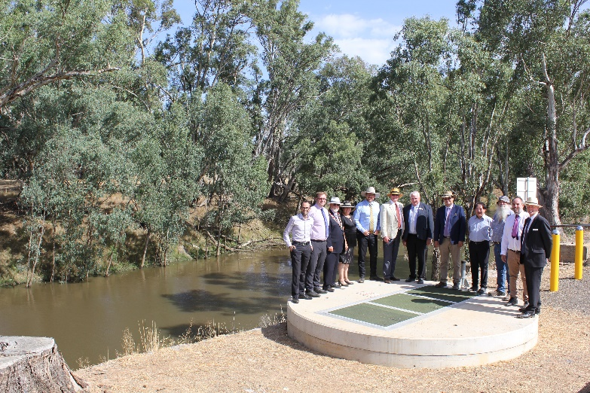**Forbes to Parkes to Gooloogong Water Pipeline**

The Parkes Integrated Water Cycle Management strategy (2004, 2015, 2020) and the 2009 CENTROC Water Security Study recommended a pipeline connection between Forbes, Parkes and Gooloogong in order to transfer water between the local water utilities and enhance water security. This project also includes the initial engineering and preliminary environmental studies for:

* 39km pipeline from Parkes Eugowra Road PS to Central Tablelands Water (CTW) Gooloogong bores site.
* A pumping station at the Eugowra Road PS with two sets of pumps, one for transferring water to Forbes and the other to Gooloogong.
* A pumping station at Gooloogong Bores site to transfer water to Parkes Eugowra Road PS.

**Seeking funding from State and Federal governments for the next step projects:**

**A. Building Better Regions Funding Round 5   
Benefits: Northparkes Mine + SAP + Parkes Shire Council**

Scope - This project will deliver various pieces of infrastructure that will augment and assist the existing water supply infrastructure. The inclusion of this infrastructure shall provide operational flexibility and reliability for the operation of the water supply scheme.

**Approx cost - $14.4M**



**Delivery timeframe**

1. **Secure funding - TBC**
2. **Establish Project - TBC**
3. **Design and Planning Approvals complete - TBC**
4. **Procurement - TBC**
5. **Construction - TBC**
6. **Project close out - TBC**

**B. Safe and Secure  
Benefits: Northparkes Mine + SAP + Parkes Shire Council**

Scope - This project will deliver infrastructure such that bulk raw water transfer from the Lachlan region to Parkes will ensure that future water demands shall be met that the existing infrastructure is not able to currently service.

**Approx cost - $47.3M**



**Delivery timeframe**

1. **Secure funding - TBC**
2. **Establish Project - TBC**
3. **Design and Planning Approvals complete - TBC**
4. **Procurement - TBC**
5. **Construction - TBC**
6. **Project close out - TBC**

# 

# Objectives and Drivers

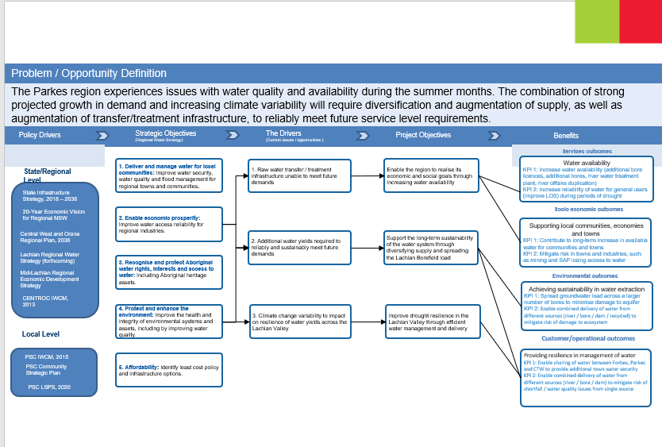

# Strategic Alignment

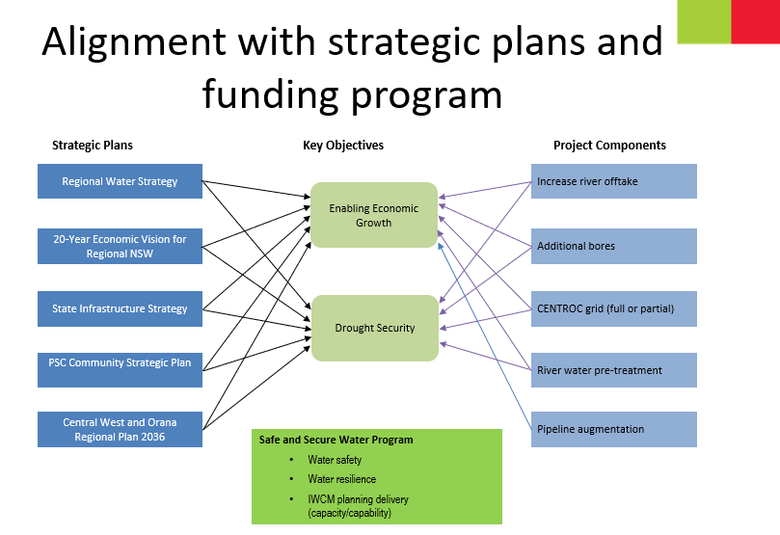

For more Information please contact

PSC Economic and Business Development Manager

Anna Wyllie 0409 739 001

[Anna.wyllie@parkes.nsw.gov.au](mailto:Anna.wyllie@parkes.nsw.gov.au)